1. Semantic Clarity (SC) → Meaning Clarity (MC)
- What Changed:
  - Semantic Clarity (SC) now merges with Natural-Language Readability (NL) into Meaning Clarity (MC).
  - MC is the combination of SC (clarity of meaning) and NL (how well the identifier reads like a phrase). This means MC will capture both the meaning and fluency of the identifier.
- Impact on Documentation:
  - The new MC factor captures both the intent of the identifier (which was SC) and how easily it is understood or pronounced (which was NL).
  - The scoring equation for MC is now the average of the SC and NL scores (or weighted as per your choice).
  - Changes to be made:
    - Remove SC and NL from the thesis and replace them with MC.
    - Update the equations for MC: MC(N)=SC(N)+NL(N)2MC(N) = \frac{SC(N) + NL(N)}{2}MC(N)=2SC(N)+NL(N)​.

2. Stylistic Convention Adherence (ST) → Naming Conformance (NC)
- What Changed:
  - Stylistic Convention Adherence (ST) now becomes Naming Conformance (NC).
  - Naming Conformance (NC) focuses on whether the identifier follows the expected naming conventions for its syntactic role (e.g., function names should start with verbs, variables with nouns).
  - The style adherence (like camelCase, PascalCase) is captured here, so the check for stylistic conventions remains in NC.
- Impact on Documentation:
  - Replace ST with NC in the thesis.
  - The equation for NC remains essentially the same: it checks the syntactic role and whether the identifier adheres to naming conventions.
- Changes to be made:
  - Update your thesis and programs to use NC instead of ST.

3. Length Appropriateness (LN) → Optimal Length (OL)
- What Changed:
  - Length Appropriateness (LN) is now Optimal Length (OL). This factor remains largely the same but is reworded to sound more streamlined and professional.
  - It continues to measure whether the length (in terms of characters and tokens) of an identifier is appropriate for its role. The ideal length is 8-20 characters and 1-3 words for variables, and 2-4 words for functions.
- Impact on Documentation:
  - Replace LN with OL in the thesis and documentation.
  - Equation for OL stays the same: OL(N)=min(Slenchars,Slentokens)OL(N) = \text{min}(S_{\text{lenchars}}, S_{\text{lentokens}})OL(N)=min(Slenchars​,Slentokens​).
- Changes to be made:
  - Update thesis and programs to use OL instead of LN.

4. Domain-Based Semantic Relevance (DR) (No Change)
- What Changed:
  - No changes here—Domain-Based Semantic Relevance (DR) remains the same.
  - It continues to measure how well the identifier uses domain-specific terminology that is relevant to the problem space of the project.
- Impact on Documentation:
  - No changes needed for DR.
- Changes to be made:
  - Keep DR as it is in both the documentation and the equation.

5. Syntactic Role Conformity (SR) → (Merged into Naming Conformance)
- What Changed:
  - Syntactic Role Conformity (SR) has been merged into Naming Conformance (NC).
  - SR measured the grammatical correctness of the identifier (e.g., functions should be verbs, variables should be nouns), which is now a part of NC.
- Impact on Documentation:
  - Remove SR from the thesis and merge the concepts into NC.
  - SR is essentially incorporated into the checks for naming conventions in NC.
- Changes to be made:
  - Update thesis and programs to remove SR.

Summary of What Needs to Change:
- Thesis:
  - Replace SC and NL with MC.
  - Replace ST with NC.
  - Replace LN with OL.
  - SR is now merged into NC—so you don't need a separate section for SR.
- Code:
  - Merge the calculations for SC and NL into MC.
  - Update the function that calculates the final score to incorporate MC, NC, OL, and DR.
- Equations:
  - MC: MC(N)=SC(N)+NL(N)2MC(N) = \frac{SC(N) + NL(N)}{2}MC(N)=2SC(N)+NL(N)​
  - Final Readability Score:

R(N)=wMC⋅MC(N)+wNC⋅NC(N)+wOL⋅OL(N)+wDR⋅DR(N)R(N) = w_{\text{MC}} \cdot \text{MC}(N) + w_{\text{NC}} \cdot \text{NC}(N) + w_{\text{OL}} \cdot \text{OL}(N) + w_{\text{DR}} \cdot \text{DR}(N)R(N)=wMC​⋅MC(N)+wNC​⋅NC(N)+wOL​⋅OL(N)+wDR​⋅DR(N)
Where:
    - wMC,wNC,wOL,wDRw_{\text{MC}}, w_{\text{NC}}, w_{\text{OL}}, w_{\text{DR}}wMC​,wNC​,wOL​,wDR​ are the weights.

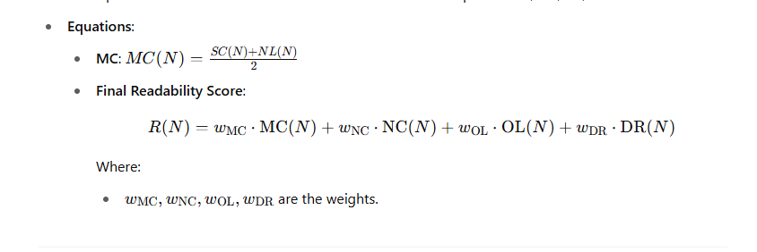
Next Steps:
- If you're ready, I can update the code to reflect these changes and run it against the dataset to produce the updated results.
- You can also start updating your thesis to reflect the simplified model with 4 key factors (MC, NC, OL, DR).
Let me know how you'd like to proceed!

